# Gullane Defibrillators

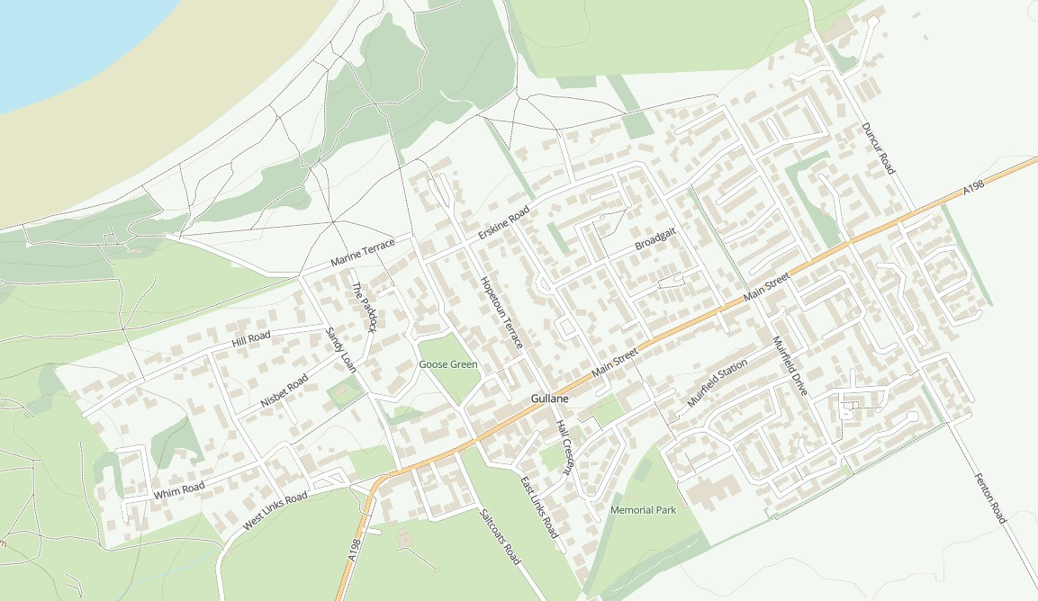

8

6

1

45

2

3

7

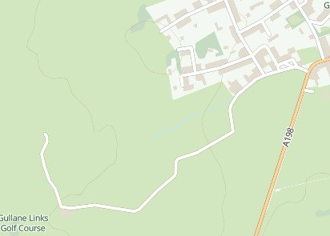

9

1. GullaneGolfClubMembersClubhouse–Inside
2. DentistMainStreet–Inside
3. GullaneGolfClubVisitorsClubhouse–Outside24hrAccess
4. GullaneBowlingClub-Inside
5. GullaneVillageHall–Outside24hrAccess
6. MedicalCenterHamiltonRoad–Inside
7. GullaneSportsHub(AstroTurf)–Outside24hrAccess
8. MuirfieldGolfClub–Inside
9. GullaneGolfClubGreenKeepersComplex(Between#2and#3Courses)

Dirleton,Drem&Archerfield Defibrillators

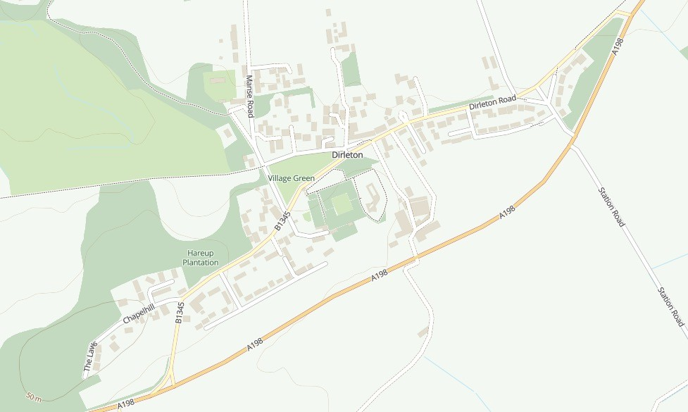

2

1

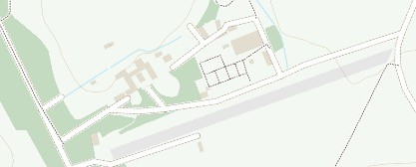

3

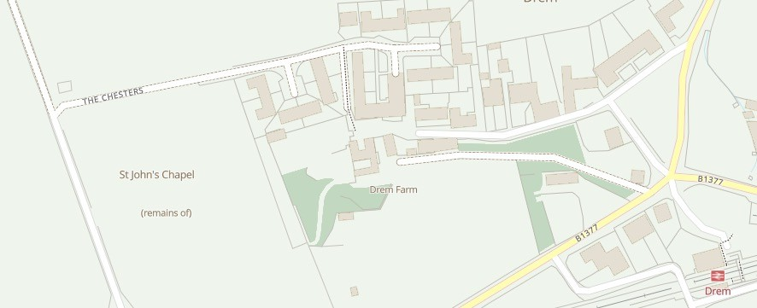

4

* 1. CastleInn–Outside24hr Access
  2. Bakersfield,10HarpensideCrescent.OppositeRoadtoYellowcraig–Outside24hrAccess
  3. ArcherfieldWalledgarden–Outside24hraccess
  4. Drem,TheChesters(underArchinBarn)–Outside24hraccess

# Aberlady Defibrillators

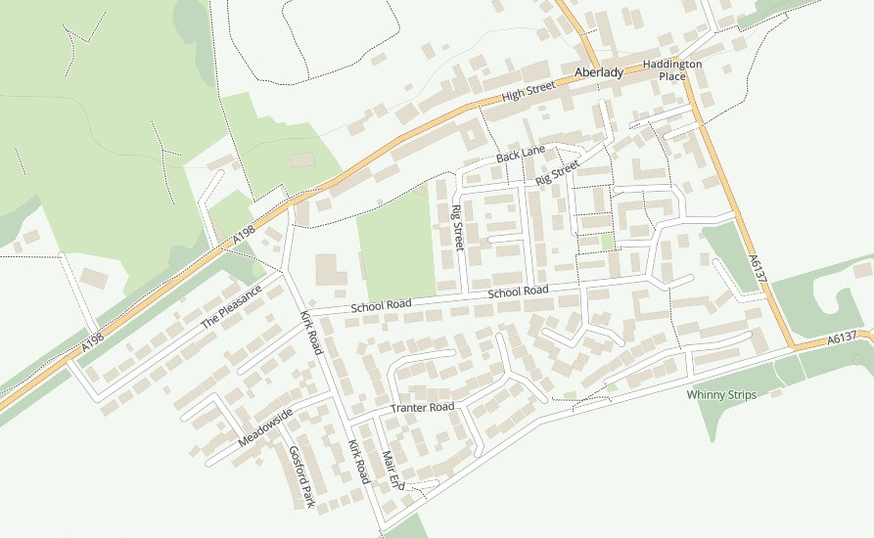

**3**

**1**

**7**

**2**

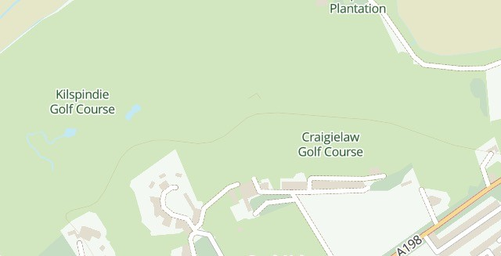

**5**

**4**

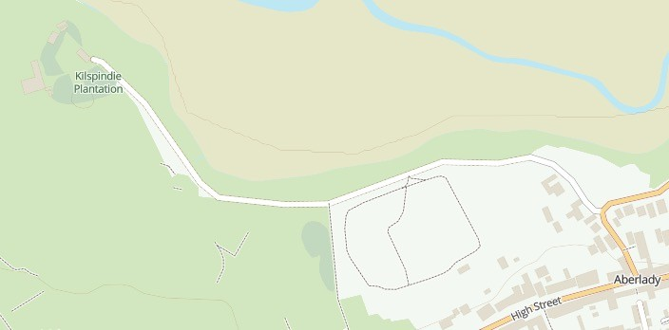

**6**

1. DucksHotel–
2. HouseNumber4,TranterRoad-Outside24hrAccess

Out of Service

1. AberladyVillageHall,SeaWynd–Outside24hrAccess
2. CraigielawGolfClubhouse–

Inside24hrAccess(AtentranceStairwell)

1. KilspindieGolfCourse–Outside24hrAccess(ToiletblockbetweenKilspindie&Craigielaw
2. KilspindieGolfClubhouse–Outside 24hr Access
3. Margiotta Village Store --Inside 7am to 8pm